Integumentary Extra Credit Worksheet – Chapter 5.
There are three major layers of skin:
The top layer is made up of ____________________ tissue and is called the _______________.
The middle layer is made of _____________________tissue and is called the ______________.
The bottom layer is made of ____________________ tissue and is called the ______________.
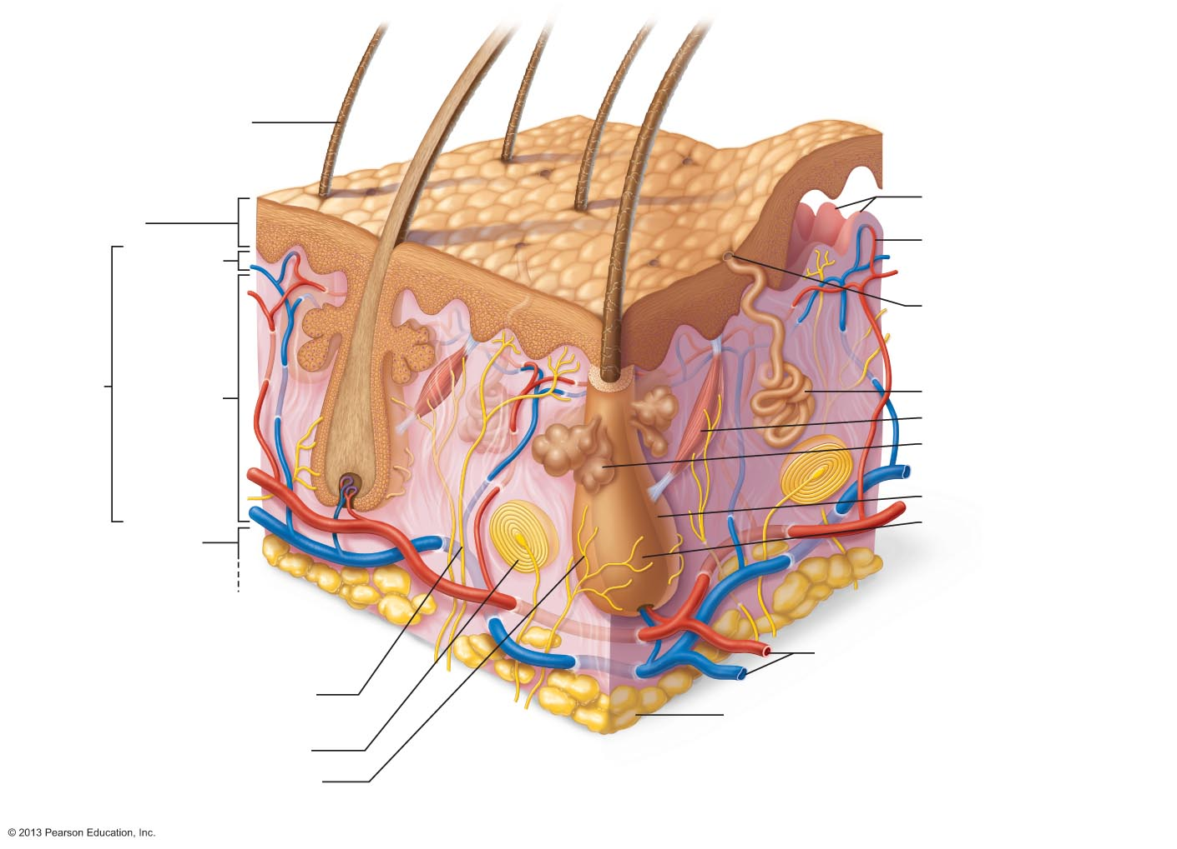
Label the diagram below:
What four cells types can be found in the epidermis? Briefly describe their function.
1. ________________________:
2. ________________________:
3. ________________________:
4. ________________________:
The epidermis is made up of 5 distinct layers. Label the 4 layers in the diagram below and describe what is going on at each level.
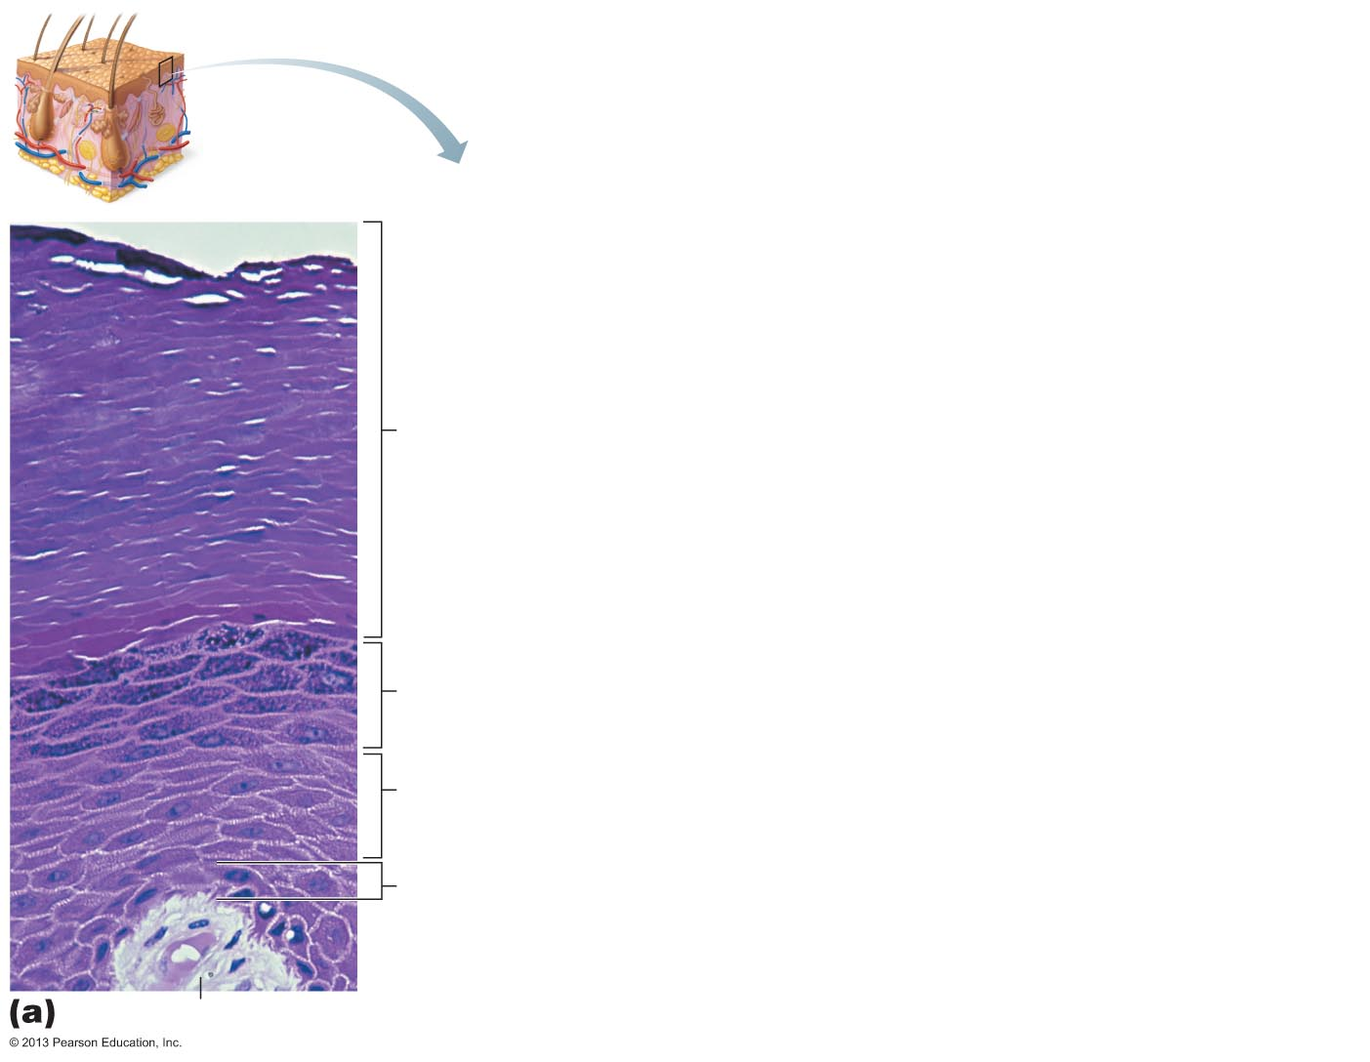
Which layer is missing? Why?
The dermis is composed of two layers: the _________________ & ___________________.
The _____________________ layer is a thin layer named for its wavy shape and is composed mainly of _______________________ connective tissue. The shape of this layer produces ________________________ on our fingertips used for ______ and leaves finger prints.
The _____________________ is bigger and is mainly composed of ______________________ connective tissue. It contains many structures including ________________, ______________, ____________________ and __________________.
The orientation of collagen in the dermis produces ____________ lines on your body which surgeons use to make incisions because they will __________ better.
The hypodermis is composed mainly of _______________ connective tissue which has three general functions: ________________, ______________________ & ____________________.
There are three pigments that contribute to skin color, list them, their colors and the cells where they are found:
1. _____________________:
2. _____________________:
3. _____________________:
Briefly describe the mechanism through which melanin is spread through the skin. Be sure to include the layers of epidermis involved and how the melanin protects the cells:

List 7 abnormal skin colors and their causes:
Abnormal Color | Cause

Sweat glands are also known as ___________________ glands.
____________________ glands secrete watery sweat, especially on the forehead, palms and soles through ducts onto the skin surface which helps _______________ the skin during exercise.
____________________ glands produce sebum in the armpits and groin through ducts connected to ___________________________.
Sebum is a mixture of sweat plus ___________________ & _________________ which, when broken down by bacteria, produces odor. It is thought this odor may have a role in __________ ___________________________.
Ceruminous glands produce ___________________.
_________________________ glands produce oil on the face and scalp to soften hair. They become active at ______________________ and if they become inflamed lead to the condition known as ______________________.
Hair has three functions:
1. Nerve cells connected to the hair detect ________________________.
2. Arrector pili muscle (smooth muscle) creates _________________________ which are thought to create a warm layer next to the skin to reduce __________________________.
3. Hair protects the skin from heat loss and ____________________________.
Label the diagram below:
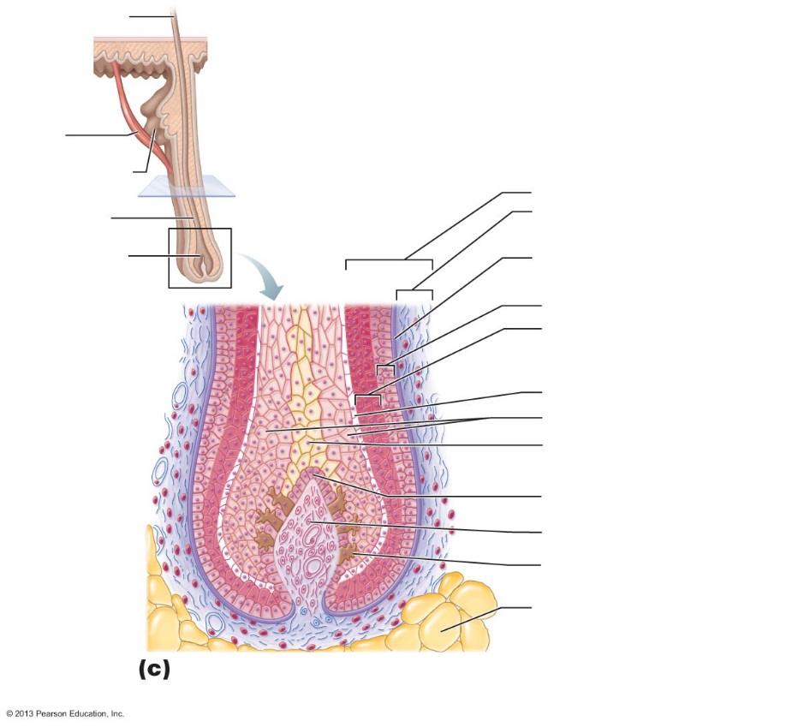

Define the following terms:
1. Hair Shaft:
2. Hair root:
3. Medulla:
4. Cortex:
5. Cuticle:
6. Follicle:
7. Hair papilla:
Hair is made by _______________________ ET and is colored by _______________________.
When a hair is circular it grows __________________, when oval it grows ________________.
The pale, fine body hair on children and adults is called ____________________.
The coarse dark hair formed after puberty is called ____________________ and is located in the _____________, __________________, __________________, _________ &___________.
During the growth phase for a single scalp hair it grows about ___ mm/week for ______ years. During the regressive phase the follicle _________________ and the hair ______________________. After the ________________________ phase, the follicle begins to grow hair again.
Explain why the growth phase is only 2 weeks for eyebrows:

The term for hair thinning is called _____________________ and can be the result of age over ______, ___________________ or genetic disorders.
Male pattern baldness is cause by a combination of ______________ and _____________. Specifically, high levels of _____________________ is damaging to hair follicles over time.

Nails are made by _____________________________ ET, the same as hair but contains more ____________________ protein.
In the nails, the cuticle is known as the ____________________________ and the quick is called the _______________________________.
The skin has 6 different functions. In the space below, name the functions and briefly describe how the skin accomplishes each function.
1.

2.

3.

4.

5.

6.

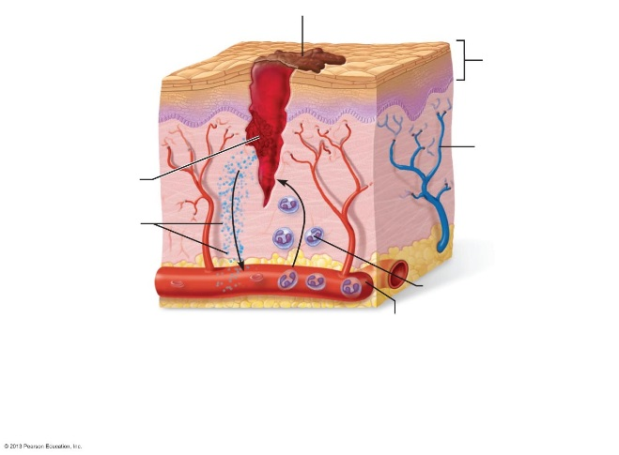
Below are three images. Label each one and next to it briefly describe the stage of healing and what is happening (These stages can be found in chapter 4).

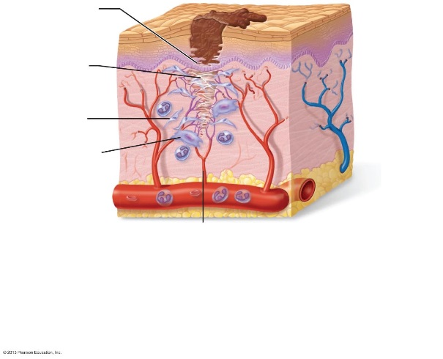

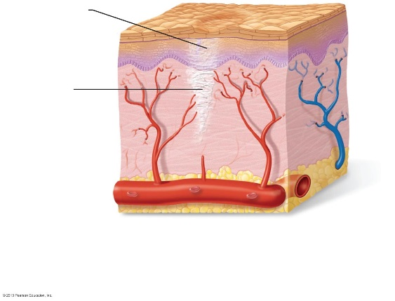

How does sun exposure cause skin cancer?

Define the following
Neoplasm:

Benign:

Malignant:

Metastasis:

Secondary Tumor:

Basal cell carcinomas originate in the Stratum _________________ of the epidermis and invade the ________________ & _________________, however they rarely _____________________.
Squamous cell carcinomas originate in the Stratum ___________________ and are commonly found in the __________, ____________, _____________ & _______________. They are often successfully treated with _________________ or _______________ before metastasis.
Malignant melanomas are tumors of ___________________ cells and are highly _________________ and resistant to ___________________.
The ABCD rule helps you to distinguish malignant melanomas from common moles. For each letter below, write the corresponding term and describe what you would be looking for.
A.
B.
C.
D.
Burns can be caused by _________, __________________, _________________, _______________, or anything that ____________________ proteins.
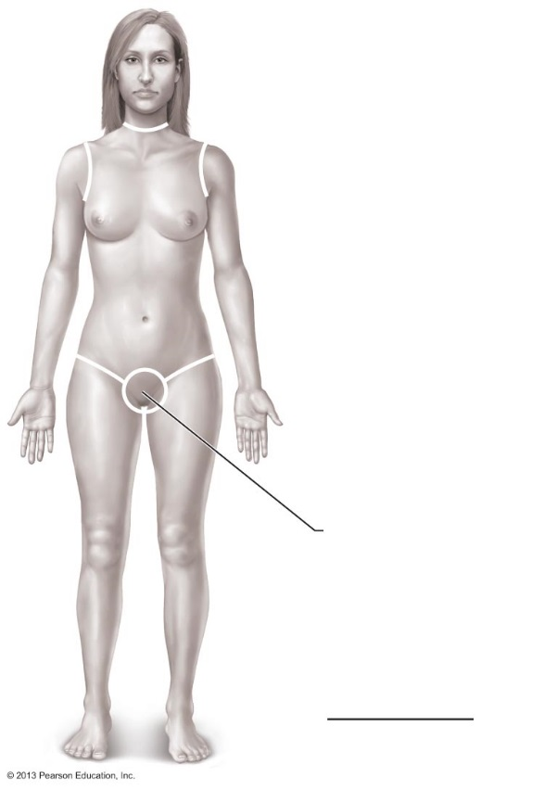
The rule of 9s is useful for describing the severity of burns. Label then write the correct percentage of the body over each region.

Anterior and posterior head & neck =
Anterior and posterior upper limbs =
Anterior and posterior trunk =
Anterior and posterior lower limbs =
Perineum = __________
Total

A first degree burn involves damage to the _____________________ layer of the skin.
A second degree burn involves damage to the ____________________ layer of the skin.
A third degree burn involves damage to the _____________________ layer of the skin
Burns are considered critical if: >25 % of the body has _________________ degree burns
>10% of the body has __________________ degree burns
The face, hands or feet have _________________ degree burns.
What are two significant complications with burns and why?

