CHM 130

Lewis Dot Formulas

and Molecular Shapes

Introduction

A chemical bond is an intramolecular (within the molecule) force holding two or more atoms together. Covalent chemical bonds are formed by valence electrons being shared between two different atoms. Both atoms attain the noble gas configuration with eight electrons (octet rule) or two electrons in their outer shell.

Octet Rule -
Atoms bond in such a way that each atom acquires eight electrons in its outer shell.

Duet Rule -
Hydrogen only requires 2 electrons to fill its outer shell and have He’s electron configuration. (1s²)

Lewis Dot Formula (also called an electron dot formula) –
Shows the valence electrons, indicating the bonding between atoms. The following guidelines will help draw the electron dot formulas correctly.

Guidelines for drawing simple Lewis dot formulas (electron dot formulas):

- Draw a skeletal structure using single bonds to connect atoms to a central atom.

- Calculate the total number of valence electrons.

- Deduct one pair of valence electrons (2e⁻ total) for each single bond drawn in Step #1, then use the remaining pairs to complete octets for the other atoms.

- If there are not enough electrons to complete an octet for each atom, because the molecule is short 2 e⁻, then move a nonbonding electron pair (an unshared pair) between two atoms that already share an electron pair to create a double bond. If the molecule is short 4 e⁻, then move nonbonding pairs to create either two double bonds or one triple bond.

- Check your work.

Example 1: Draw the electron dot formula and build the molecular model of water, H₂O.
(1) Draw a skeletal structure. Can hydrogen atoms be a central atom?
(2) H = 1 valence electron x 2 = 2 valence electrons; O = 6 valence electrons for a total of 8 valence electrons.
(3) 8 valence electrons - 4 electrons committed in single bonds = 4 electrons to distribute. Place two electron pairs on O to complete its octet.
(4) Check. There are 2 electrons on each H and there are 8 electrons around the central O atom.

Molecule | # of valence e⁻ | Lewis Structure
H₂O | 2(1) + 6 = 8e-

The bonds depicted in a Lewis dot formula (an electron dot formula) can form three types of bonds depending on the number of pairs of electrons shared between the two atoms forming the bond. The three types of bonds are:

Single Bond – sharing one pair of electrons (2e⁻ total)
Double Bond – sharing two pairs of electrons (4e⁻ total)
Triple bond – sharing three pairs of electrons (6e⁻ total)

Example 2: Draw the electron dot formula and build the molecular model of sulfur trioxide, SO₃.
(1) Draw a skeletal structure with a central S atom.
(2) Calculate the total number of valence electrons.
(3) Deduct a pair of electrons for each of the single bonds drawn in Step #1. Use the remaining pairs to complete octets for each of the other atoms.
(4) If there are not enough electrons to provide an octet for each atom, move a nonbonding (unshared) electron pair between two atoms that already share an electron pair.
(5) Check your work. [Hint: Did you need a double bond?]

Molecule | # of valence e⁻ | Lewis Structure
SO₃ | 6 + 3(6) = 24e-

Example 3: Draw the electron dot formula and build the molecular model of hydrogen cyanide, HCN (hydrocyanic acid).
(1) Draw a skeletal structure that connects the atoms in the same order as shown in the formula.
(2) Calculate the total number of valence electrons.
(3) Deduct a pair of electrons for each of the single bonds drawn in Step #1. Use the remaining pairs to complete octets for each of the other atoms.
(4) If there are not enough electrons to provide an octet for each atom, consider moving nonbonding electron pairs between two atoms that already share an electron pair.
(5) Check your work. [Hint: Did you need a triple bond?]

Molecule | # of valence e⁻ | Lewis Structure
HCN | 1 + 4 + 5 = 10e-

Lewis dot formulas (electron dot formulas) can also be drawn for ions. A monoatomic ion is a simple ion consisting of only one atom and having a positive or a negative charge. A polyatomic ion (or oxyanion) can contain two or more atoms held together by covalent bonds with an overall positive or negative charge. The following guidelines will help draw the electron dot formulas for ions correctly.

Amended guidelines for drawing Lewis dot formulas (electron dot formulas) for polyatomic ions:
(1) Draw a skeletal structure of the molecule.
(2) Calculate the total number of valence electrons. If the ion is negatively charged, then add electrons for each charge; if the ion is positively charged, then subtract electrons for each charge.
(3-5) The other rules are the same.

Example 4: Draw the electron dot formula and build the molecular model of ammonium ion, NH₄⁺.

Molecule | # of valence e⁻ | Lewis Structure
NH₄⁺ | 5 + 4(1) - 1 = 8e-

Example 5: Draw the electron dot formula and build the molecular model of nitrate ion, NO₃⁻.

Molecule | # of valence e⁻ | Lewis Structure
NO₃⁻ | 5 + 3(6) + 1 = 24e-

The Valence Shell Electron Pair Repulsion Theory (VSEPR) states the electron pairs surrounding an atom tend to repel each other and the shape of the molecule is the result of this electron pair repulsion. This model portrays bonding and nonbonding electron pairs as occupying specific positions around the central atom in the molecule.

Hybridization refers to the mixing of atomic orbitals on the central atom. The number of regions of electron density around the central atom indicates the number of atomic orbitals that must be used to create the hybrid or molecular orbitals.
Two regions of electron density = two atomic orbitals (s + p) = an sp hybrid orbital
Three regions of electron density = three atomic orbitals (s + p + p) = an sp² hybrid orbital
Four regions of electron density = four atomic orbitals (s + p + p + p) = and sp³ hybrid orbital

Electron Group Geometry indicates the arrangement of bonding and nonbonding electron groups around the central atom without differentiation. All groups are considered equivalent. The three molecules below all contain four electron groups and no distinction is made between bonding and nonbonding electron groups in describing their electron group geometry. Make a molecular model of each and observe the orientation of the four electron groups in each molecule.

CH₄ – tetrahedral electron pair geometry
NH₃ – tetrahedral electron pair geometry
H₂O – tetrahedral electron pair geometry

Molecular Geometry, or molecular shape as it is sometimes called, indicates the arrangement of atoms around the central atom as a result of electron group repulsion. There are two considerations in describing the molecular shape of a molecule:

(1) The number of regions of electron density around the central atom. This number dictates the electron group geometry around the central atom and the approximate bond angles between atoms because of repulsion between electron groups. Three possible electron geometries are considered in this course:
Two regions of electron density = linear electron geometry (180˚ bond angle)
Three regions of electron density = trigonal planar electron geometry (120˚ bond angle)
Four regions of electron density = tetrahedral electron geometry (109.5˚ bond angle)

(2) The number of bonding and nonbonding groups of electrons around the central atom. The atoms in a molecule are positioned in space because of the repulsion between electron groups around the central atom (i.e.; the electron geometry). The shape of the molecule depends on how many of the electron groups around the central atom are bonded to atoms and how many are unshared. Bond angle is defined as the angle formed by any two atoms bonded to a central atom. The nonbonded electron pairs create a larger cloud of electrons and create a greater repulsion than do the bonded electron groups. The effect of nonbonded pairs is to compress the bond angle. The effect is seen in the three possible bond angles considered in this activity:
109.5º – formed by a tetrahedral molecular shape, for example CH₄, in which all electrons are bonding electrons.
107º – formed by a trigonal pyramidal molecular shape, for example NH₃, in which three groups are bonding and one pair is unshared.
104.5º – formed by a (tetrahedral) bent molecular shape, for example H₂O, in which two groups are bonding and two pairs are unshared.
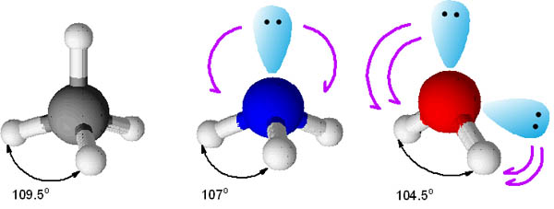

Another consideration is molecular polarity. Polar bonds are a type of covalent bond in which the electrons that are shared are drawn more closely to one of the atoms than the other. Electronegativity (E_{n}) is a numerical value that describes the ability of an atom to attract electrons in a chemical bond. The general trends in electronegativity are as follows:
Left to right - increase in E_{n} (nonmetals have high E_{n}, metals have low E_{n})
Down a group - decrease in E_{n} (small atoms have high E_{n}, large atoms have low E_{n})
F = 4.0 and Cs = 0.7

The degree of polarity can be calculated by taking the difference in E_{n} between the two atoms involved in the bond. For CHM130 the following guidelines will be used:
If the ΔE_{n} is < 0.4, the bond is considered to be nonpolar (the electrons are shared equally within the bond)
If the ΔE_{n} is between 0.5 and 2.0, the bond is considered to be polar (the electrons are shared but not equally within the bond)
If the ΔE_{n} is > 2.0, the bond is considered to be ionic (the electrons are completely transferred from one atom to the other)

For example: H-Cl H = 2.1 & Cl = 3.0. The difference in E_{n} = 3.0 - 2.1 = 0.9. Therefore, the bond between H and Cl is polar and the electron pair is attracted more towards the Cl than the H, because Cl has a higher electronegativity. This makes the Cl partially negative and the H partially positive.

The delta notation (δ) for polar bonds shows this partially charged situation by using δ⁻ to indicate the negative region and δ⁺ to indicate the positive region.
δ⁺ H - Cl δ⁻
The following guidelines are for CHM 130 level ONLY:

Polar Molecules are created when the polar bonds within the molecule add together to form a net dipole moment.

A molecule that contains only nonpolar bonds tends to be a nonpolar molecule (example: CH₄)
A binary molecule (2 atoms) will be nonpolar if the bond is nonpolar (example: Br₂) or polar if the bond is polar (example: HCl)
For molecules that contain 3 or more atoms and contain polar bonds, the molecular geometry of the molecule must be considered.

Molecular shapes that are highly symmetric (meaning no lone pairs on the central atom) tend to be nonpolar
All atoms bonded to the central atom must be the same (example: CCl₄, CO₂, BF₃)
Molecular shapes that are asymmetric (meaning they contain 1 or more lone pairs on the central atom) tend to be polar
Also applies to molecules that have different atoms bonded to the central atom (example: CH₃Cl, CH₂Cl₂, CHCl₃, NF₃, H₂O)

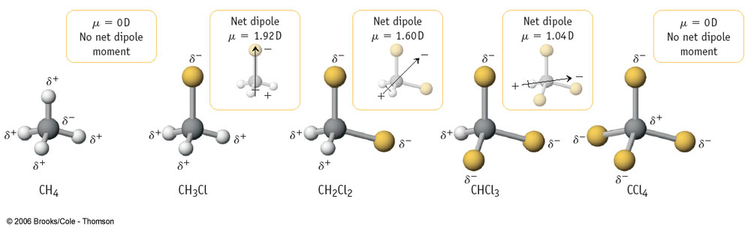

 | Symmetric Shape  (no lone pairs on the central atom) | Asymmetric Shape  (the central atom has at least one lone pair)
Contains only nonpolar bonds | Nonpolar Molecule | Weakly Polar
Contains at least one polar bond | Nonpolar – if all bonds are the same  Polar – if bonds are different | Polar

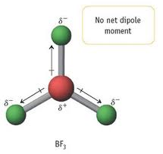
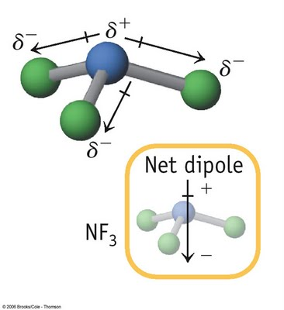
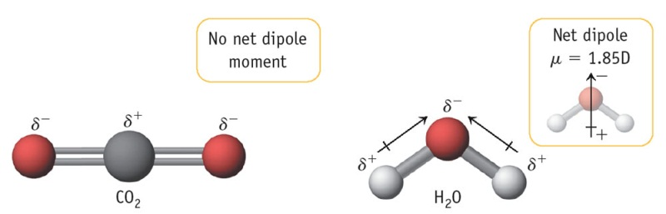

Name:__ Answer Key __ Section & Date:_________________ Lab Partner:________________________________________

CHM 130LL Experiment #7 – Lewis Dot Structures Report Sheet

Part A – Molecules with single bonds

Molecule | # of valence e⁻ | Lewis Structure | Regions of e⁻ density | Electronic group geometry (name) | Hybridization (sp, sp², sp³) | # of Bonding Regions | # of  Lone Pairs | Shape of the molecule (drawing and name) | Polar or Nonpolar (P or NP)
H₂O | 2(1) + 6 = 8e- |  | 4 | Tetrahedral | sp³ | 2 | 2 | Bent | P
Br₂ | 2(7) = 14e- |  |  |  |  |  |  | Linear | NP
HCl | 1 + 7 = 8e- |  |  |  |  |  |  | Linear | P
ICl | 7+7 = 14e- |  |  |  |  |  |  | Linear | P
CH₄ | 4 + 4(1) = 8e- |  | 4 | Tetrahedral | sp³ | 4 | 0 | Tetrahedral | NP
Molecule | # of valence e⁻ | Lewis Structure | Regions of e⁻ density | Electronic group geometry (name) | Hybridization (sp, sp², sp³) | # of Bonding Regions | # of  Lone Pairs | Shape of the molecule (drawing and name) | Polar or Nonpolar (P or NP)
CH₂Cl₂ | 4+2(1)+ 2(7) = 20e- |  | 4 | Tetrahedral | sp³ | 4 | 0 | Tetrahedral | P
HOOH | 2(1) + 2(6) = 14e- |  | 4 | Tetrahedral | sp³ | 2 | 2 | Bent | P
NH₃ | 5 + 3(1) =8e- |  | 4 | Tetrahedral | sp³ | 3 | 1 | Trigonal pyramidal | P
N₂H₄ | 2(5) + 4(1) = 14e- |  | 4 | Tetrahedral | sp³ | 3 | 1 | Trigonal pyramidal | P

Part B – Molecules with double bonds

Molecule | # of valence e⁻ | Lewis Structure | Regions of e⁻ density | Electronic group geometry (name) | Hybridization (sp, sp², sp³) | # of Bonding Regions | # of  Lone Pairs | Shape of the molecule (drawing and name) | Polar or Nonpolar (P or NP)
SO₃ | 6 + 3(6) = 24e- |  | 3 | Trigonal planar | sp² | 3 | 0 | trigonal planar | NP
O₂ | 2(6) = 12e- | 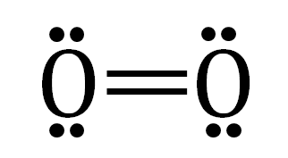 |  |  |  |  |  | Linear | NP
C₂H₄ | 2(4) + 4(1) = 12e- |  | 3 | Trigonal planar | sp² | 3 | 0 | Trigonal planar | NP
HONO | 1 + 2(6) + 5 = 18e- |  | N  3 | N  Trigonal planar | N  sp² | N  2 | N  1 | Bent | P
SO₂ | 6 + 2(6) = 18e- |  | 3 | Trigonal planar | sp² | 2 | 1 | Bent | P

Part C – Molecules with triple bonds

Molecule | # of valence e⁻ | Lewis Structure | Regions of e⁻ density | Electronic group geometry (name) | Hybridization (sp, sp², sp³) | # of Bonding Regions | # of  Lone Pairs | Shape of the molecule (drawing and name) | Polar or Nonpolar (P or NP)
HCN | 1 + 4 + 5 = 10e- |  | 2 | Linear | sp | 2 | O | Linear | P
N₂ | 2(5) = 10e- | 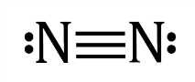 |  |  |  |  |  | Linear | NP
HOCN | 1 + 6 + 4 + 5 = 16e- |  | C  2 | C  linear | C  sp | C  2 | C  0 | Linear | P

Part D – Molecules with two double bonds

Molecule | # of valence e⁻ | Lewis Structure | Regions of e⁻ density | Electronic group geometry (name) | Hybridization (sp, sp², sp³) | # of Bonding Regions | # of  Lone Pairs | Shape of the molecule (drawing and name) | Polar or Nonpolar  (P or NP)
CO₂ | 4 + 2(6) = 16e- |  | 2 | Linear | sp | 2 | 0 | Linear | NP
CH₂CCH₂ | 3(4) + 4(1) = 16e- |  | 2 | Linear | sp | 2 | 0 | Linear | NP
Part E – Polyatomic Ions

Molecule | # of valence e⁻ | Lewis Structure | Regions of e⁻ density | Electronic group geometry (name) | Hybridization (sp, sp², sp³) | # of Bonding Regions | # of  Lone Pairs | Shape of the molecule (drawing and name) | Polar or Nonpolar (P or NP)
NH₄⁺ | 5 + 4(1) - 1 = 8e- |  | 4 | Tetrahedral | sp³ | 4 | 0 | Tetrahedral | NP
NO₃⁻ | 5 + 3(6) + 1 = 24e- | 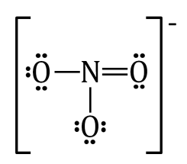 | 3 | Trigonal planar | sp² | 3 | 0 | Trigonal planar | NP
H₃O⁺ | 3(1) + 6 -1 = 8e- |  | 4 | Tetrahedral | sp³ | 3 | 1 | Trigonal pyramidal | P
BrO₃⁻ | 7 + 3(6) + 1 = 26e- |  | 4 | Tetrahedral | sp³ | 3 | 1 | Trigonal pyramidal | P
CO₃²⁻ | 4 + 3(6) + 2 = 24e- |  | 3 | Trigonal planar | sp² | 3 | 0 | Trigonal planar | NP
SO₄²⁻ | 6 + 4(6) + 2 = 32e- |  | 4 | Tetrahedral | sp³ | 4 | 0 | Tetrahedral | NP
Part F – Mixed

Molecule | # of valence e⁻ | Lewis Structure | Regions of e⁻ density | Electronic group geometry (name) | Hybridization (sp, sp², sp³) | # of Bonding Regions | # of  Lone Pairs | Shape of the molecule (drawing and name) | Polar or Nonpolar (P or NP)
SiH₄ | 4 + 4(1) = 8e- |  | 4 | Tetrahedral | sp³ | 4 | 0 | Tetrahedral | NP
PH₃ | 5 + 3(1) = 8e- |  | 4 | Tetrahedral | sp³ | 3 | 1 | Trigonal pyramidal | Weakly P
H₂S | 2(1) + 6 = 8e- |  | 4 | Tetrahedral | sp³ | 2 | 2 | Bent | Weakly P
H₂Se | 2(1) + 6 = 8e- |  | 4 | Tetrahedral | sp³ | 2 | 2 | Bent | Weakly P
CH₂O | 4 + 2(1) + 6 = 12e- |  | 3 | Trigonal planar | sp² | 3 | 0 | Trigonal planar | P
BF₃ | 3 + 3(7) = 24e- |  | 3 | Trigonal planar | sp² | 3 | 0 | Trigonal planar | NP

