Entrance Exit Date________ Name _______________________________________

Assignment:

__________________________________________________________________________________________________________________________________________________________

5 | 4 | 3 | 2 | 0
Knowledge + | Knowledge | Not Yet | No Effort | No Entry
You have demonstrated in-depth mastery of content through elaboration. Effort is evidenced. | You have demonstrated mastery of the content, but with a little more effort you would produce superior work. | There is evidence that you are putting forth effort to learn the content, but you are missing important information that is essential to demonstrating comprehension. It would be a good idea to meet with your instructor for help. | There is so little evidence provided that the instructor cannot determine if the student comprehends content or has put forth effort to learn material. | No submission to evaluate. No late entries accepted!
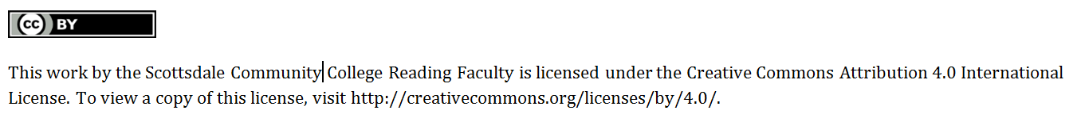

Entrance Exit Date________ Name _______________________________________

Assignment:

__________________________________________________________________________________________________________________________________________________________

5 | 4 | 3 | 2 | 0
Knowledge + | Knowledge | Not Yet | No Effort | No Entry
You have demonstrated in-depth mastery of content through elaboration. Effort is evidenced. | You have demonstrated mastery of the content, but with a little more effort you would produce superior work. | There is evidence that you are putting forth effort to learn the content, but you are missing important information that is essential to demonstrating comprehension. It would be a good idea to meet with your instructor for help. | There is so little evidence provided that the instructor cannot determine if the student comprehends content or has put forth effort to learn material. | No submission to evaluate. No late entries accepted!
